## **Installing the Driver**

The USB to serial port chip of this control board is CH340G. So you need to install the driver for the chip. You can click the driver file here <https://kd.kidsbits.cc/KD0001-Driver> to download it.

In different systems, the driver installation is similar. Here we start to install the driver on the Win7 system.

Plug one end of your USB cable into the square interface of the kidsbits coding box and the other into a USB socket on your computer.

When you connect the kidsbits coding box to your computer at the first time, right click your “Computer” —>for “Properties”—> click the “Device manager”, under Other devices, you should see the “USB2.0-Serial”.

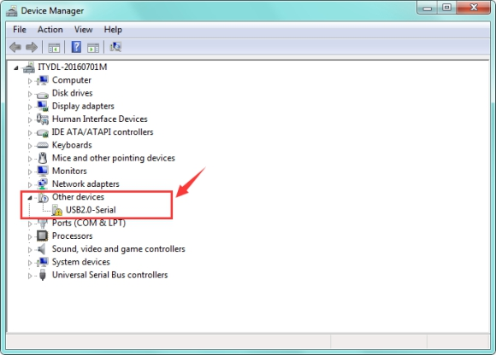

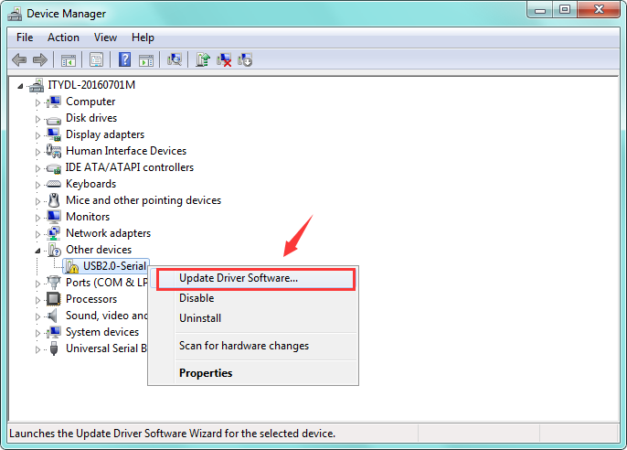Then right-click on the USB2.0-Serial and select the top menu option (Update Driver Software...) shown as the figure below.

Then it will be prompted to either “Search Automatically for updated driver software” or “Browse my computer for driver software”. Shown as below. In this page, select “Browse my computer for driver software”.

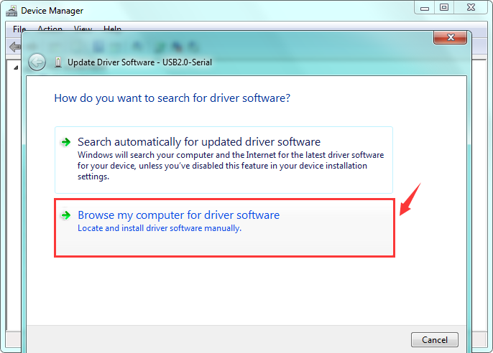

After that, select the option to browse and navigate to the “drivers” folder of usb-ch341 installation.

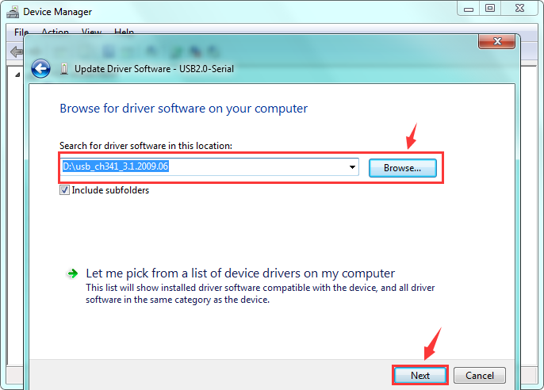

Once the software has been installed, you will get a confirmation message. Installation completed, click “Close”.

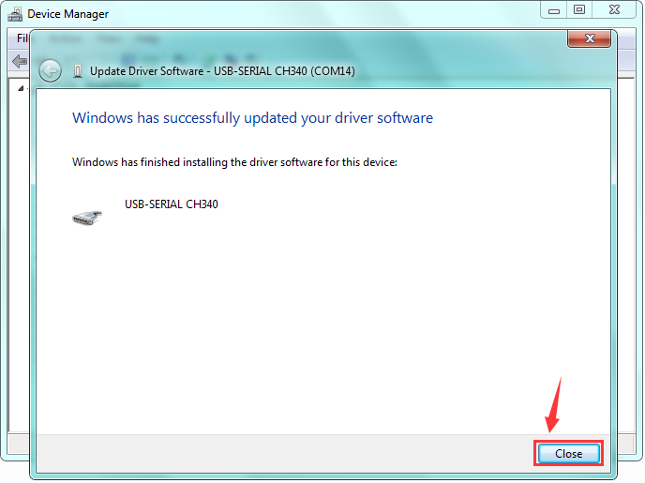

Up to now, the driver is installed well. Then you can right click “Computer” —>“Properties”—>“Device manager”, you should see the device as the figure shown below.

